CONFIGURING READ ONLY ROUTING LIST FOR ALWAYSON AVAILABILITY GROUP
https://jbswiki.com/2017/09/06/configuring-read-only-routing-list-for-alwayson-availability-group/
Environment

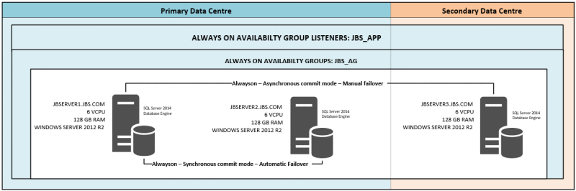
-> SQL Server instances as seen in the SQL Server Management Studio,
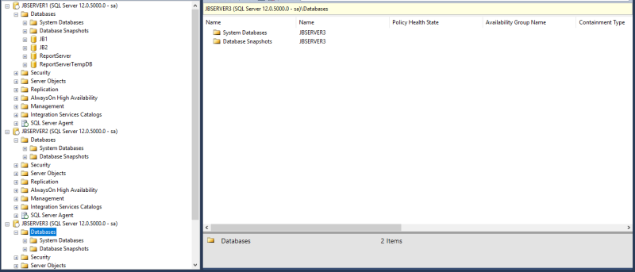
-> Adding the databases to Availability group,
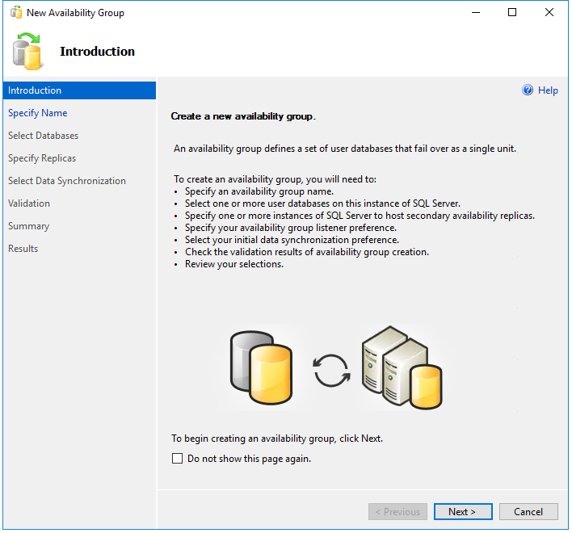
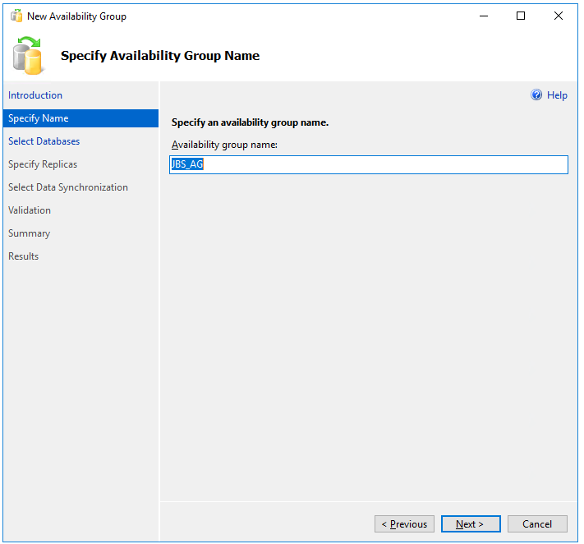
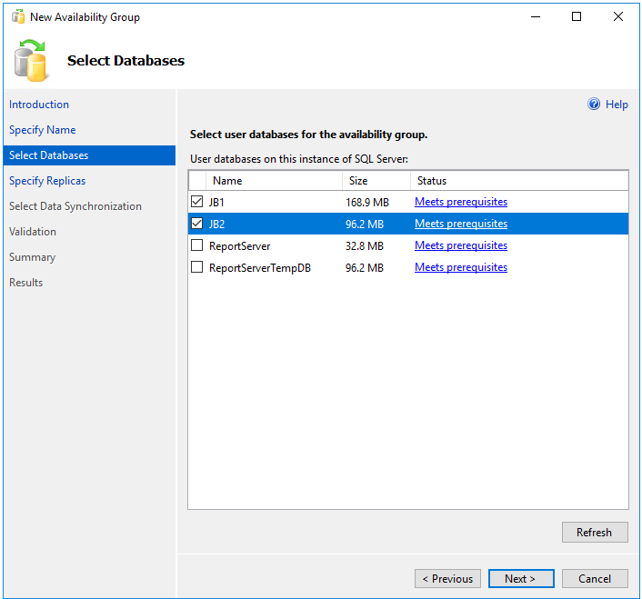
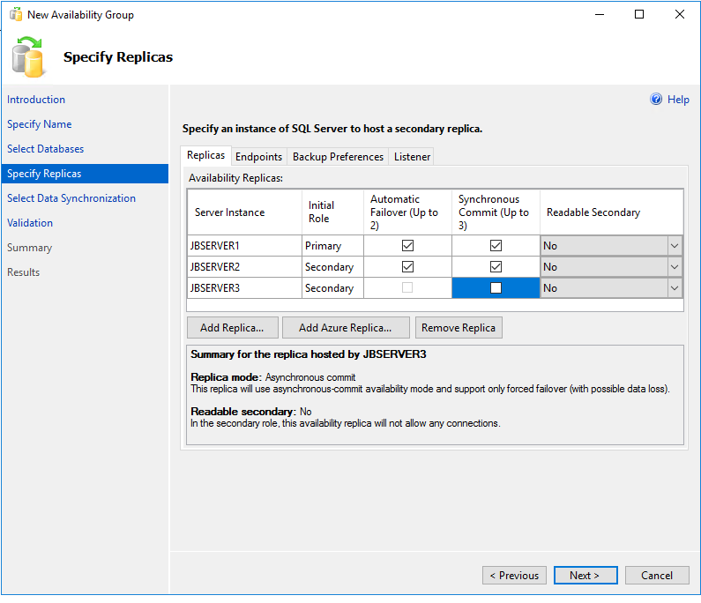
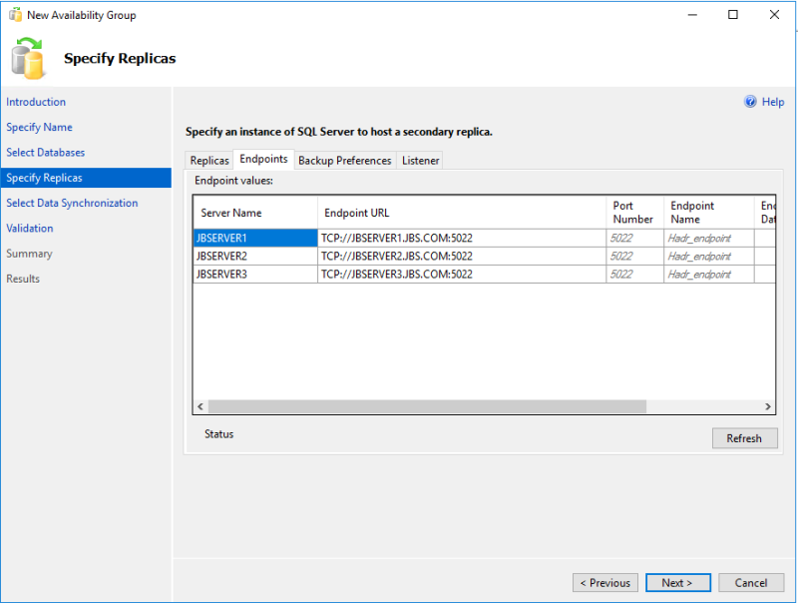
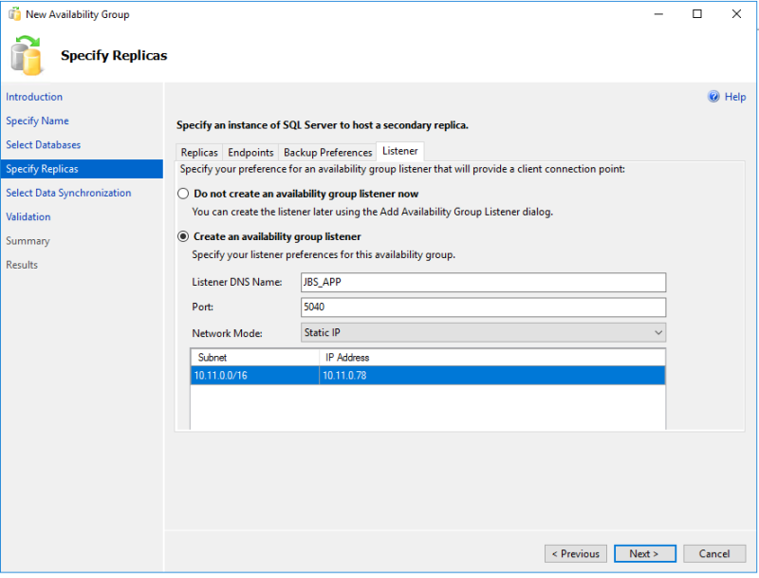
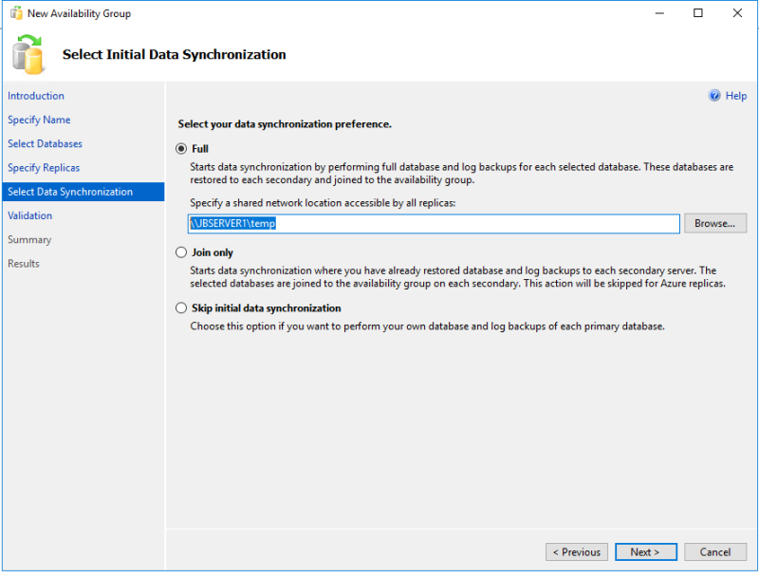
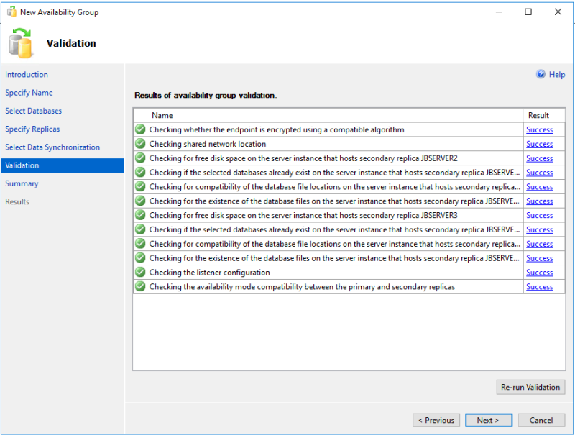
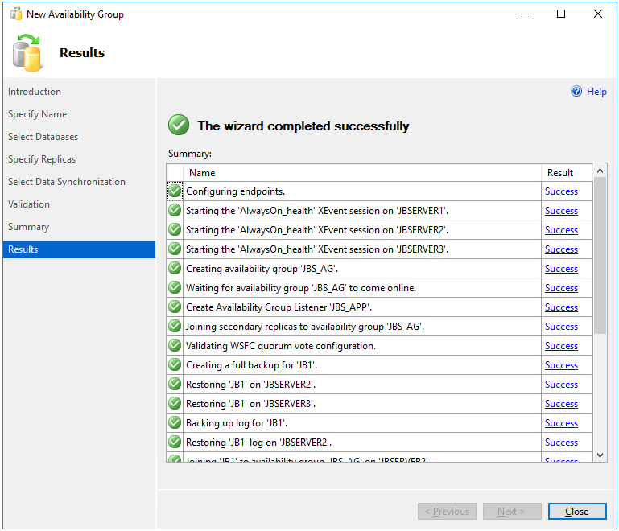
-> Availability group as seen in SQL Server Management Studio,
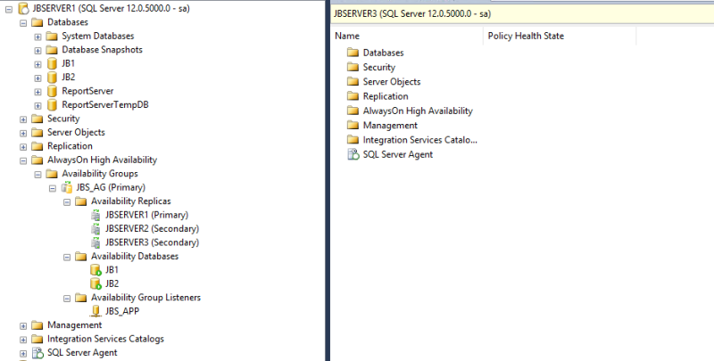
-> Configuring ReadOnly Routing List using the below query,
ALTER AVAILABILITY GROUP JBS_AG
MODIFY REPLICA ON
N'JBSERVER1' WITH
(SECONDARY_ROLE (ALLOW_CONNECTIONS = READ_ONLY));
ALTER AVAILABILITY GROUP JBS_AG
MODIFY REPLICA ON
N'JBSERVER1' WITH
(SECONDARY_ROLE (READ_ONLY_ROUTING_URL = N'TCP://JBSERVER1.JBS.COM:1433'));
ALTER AVAILABILITY GROUP JBS_AG
MODIFY REPLICA ON
N'JBSERVER2' WITH
(SECONDARY_ROLE (ALLOW_CONNECTIONS = READ_ONLY));
ALTER AVAILABILITY GROUP JBS_AG
MODIFY REPLICA ON
N'JBSERVER2' WITH
(SECONDARY_ROLE (READ_ONLY_ROUTING_URL = N'TCP://JBSERVER2.JBS.COM:1433'));
ALTER AVAILABILITY GROUP JBS_AG
MODIFY REPLICA ON
N'JBSERVER3' WITH
(SECONDARY_ROLE (ALLOW_CONNECTIONS = READ_ONLY));
ALTER AVAILABILITY GROUP JBS_AG
MODIFY REPLICA ON
N'JBSERVER3' WITH
(SECONDARY_ROLE (READ_ONLY_ROUTING_URL = N'TCP://JBSERVER3.JBS.COM:1433'));
ALTER AVAILABILITY GROUP JBS_AG
MODIFY REPLICA ON
N'JBSERVER1' WITH
(PRIMARY_ROLE (READ_ONLY_ROUTING_LIST=('JBSERVER3','JBSERVER2')));
ALTER AVAILABILITY GROUP JBS_AG
MODIFY REPLICA ON
N'JBSERVER2' WITH
(PRIMARY_ROLE (READ_ONLY_ROUTING_LIST=('JBSERVER3','JBSERVER1')));
ALTER AVAILABILITY GROUP JBS_AG
MODIFY REPLICA ON
N'JBSERVER3' WITH
(PRIMARY_ROLE (READ_ONLY_ROUTING_LIST=('JBSERVER2','JBSERVER1')));
-> The Read-Routing list order is as below,
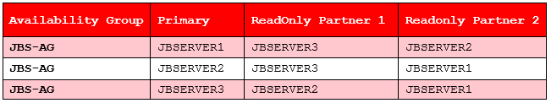
-> Checking if Read-Routing List is working using SQLCMD. After we use the switch -KReadOnly, the servername returned is JBSERVER3 which proves that the readonly queries are routed to the secondary.
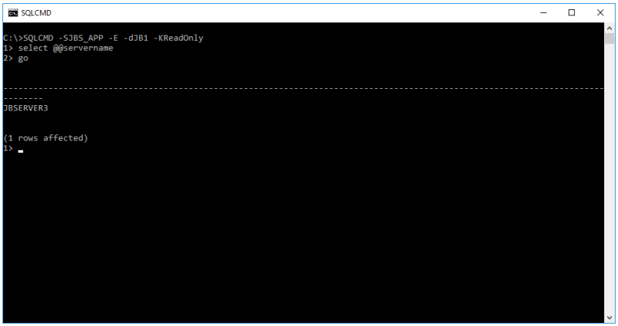
-> Verifying Read-Only list using SQL Server Management Studio,
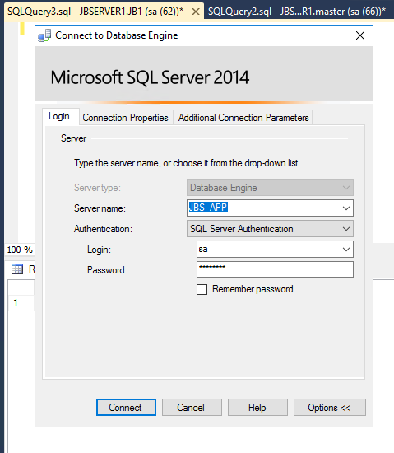
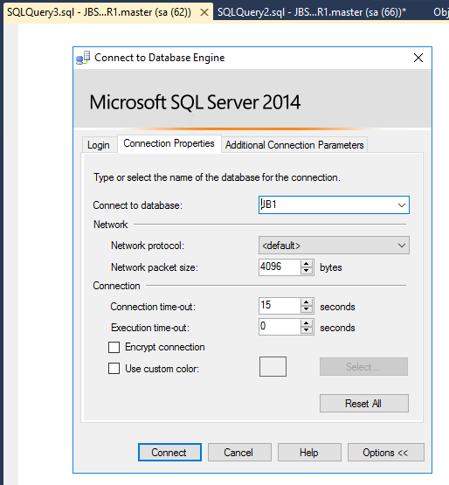
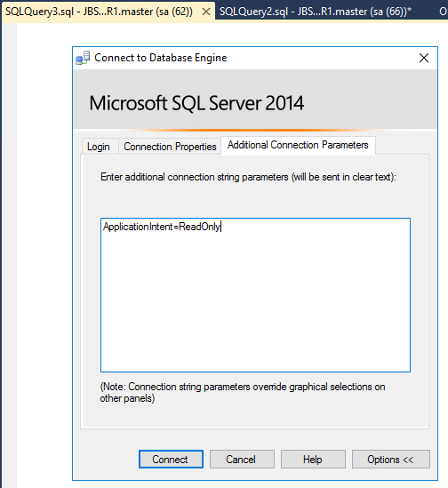
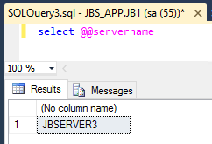
Thank You,
Vivek Janakiraman

